San Jose State University

EE250 (Section 2) Fall 2019 Prof. Kamali

Problem Set #9

- Problem 9.46
Assume P[Z(0)=1]= P[Z(0)=0]=1/2.
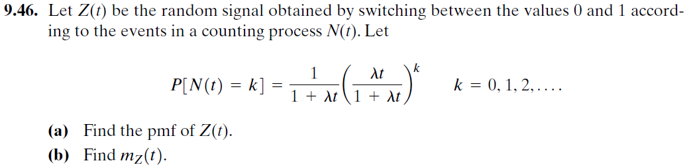

- [Final Exam, Fall 2008] Consider the random process 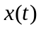which is defined in the following figure where 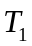 and 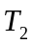are independent uniform random variables in 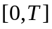. Find 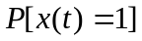for 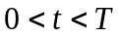.

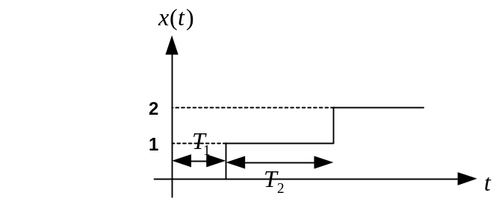

- [Final Exam, Fall 2008] Suppose is an exponential random variable with parameter. The parameter, however, is random itself and can take on the value of 1 and 2 with equal probability. Find the pdf of (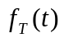).
- [Final Exam, Spring 2005] Suppose is a Wiener process with parameter 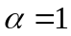. Find 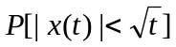.
- [Final exam, Spring 2015] Suppose 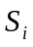 (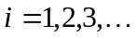) are the arrival times of a Poisson process with the average rate of 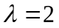 and 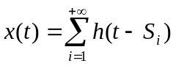where 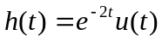.

- Find 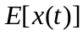.
- What is the limit of when 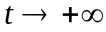.

- [Final exam, Fall 2015] A continuous-time random process 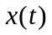starts at 0 at 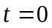and alternates between 0 and 1 every time a Poisson event with average rate of occurs (following figure).

- Find 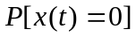 .
- Find 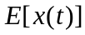 .
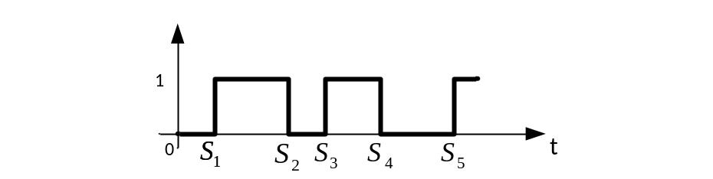

- [Final exam, Fall 2017] Consider the random process 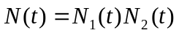 where 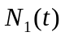and 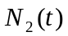 are two independent Poisson random processes with average rates of 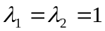.

- Does 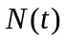have independent increment property?
- Find 

